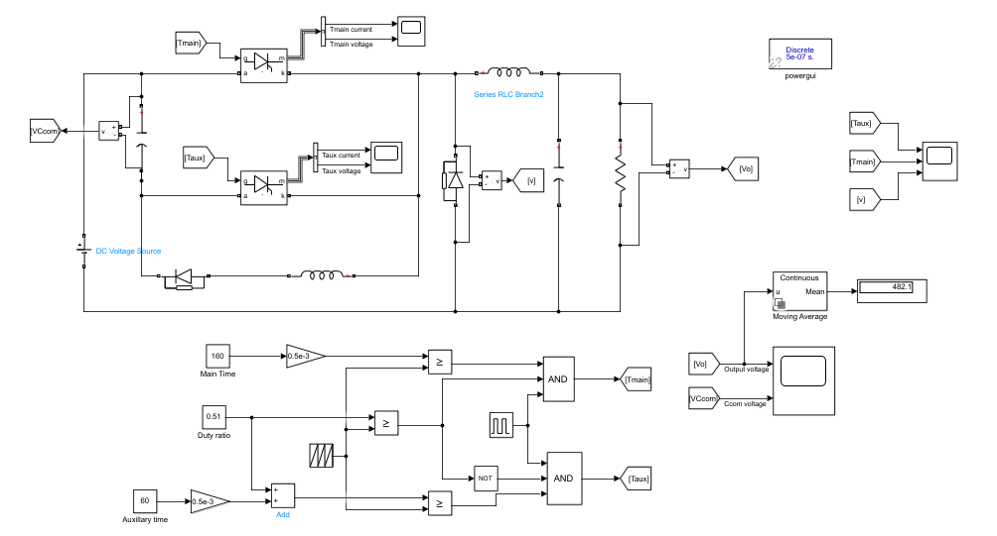

[1] Choose the commutation inductor 𝐿𝑐 in such a way that the peak current through the main thyristor remains at 95 A (±5% is considerable).

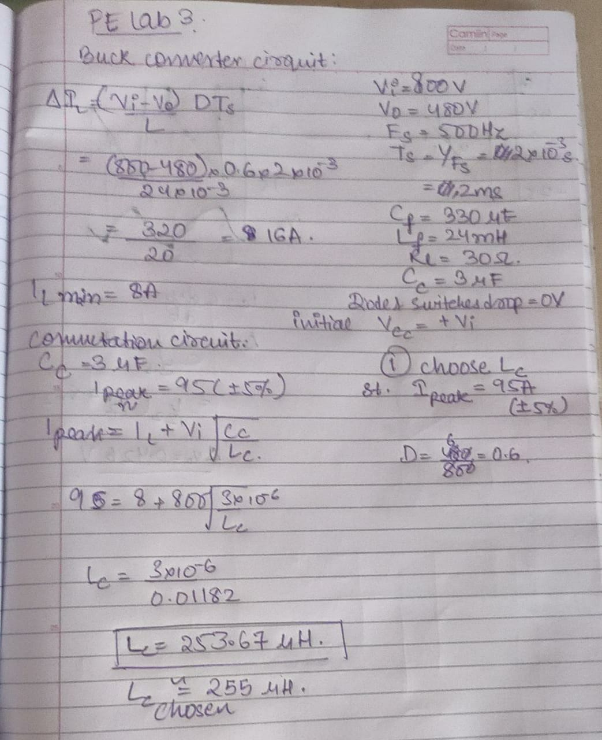

Lc used is ~ 254e-6 H

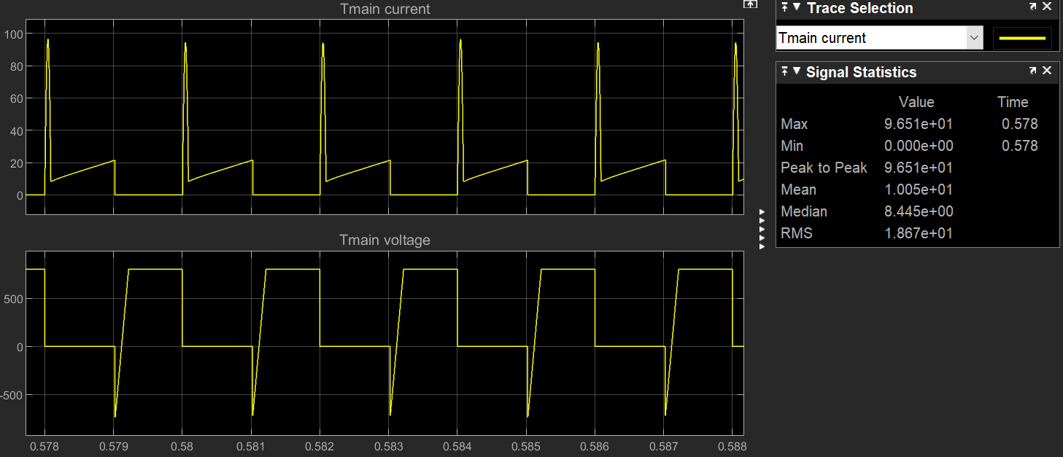

Experimental I main max is 96.7A.

The theory I main max is 95A.

[2]

The theoretical duty cycle should be 0.6. But, we have used a thyristor as a switching device so, the switching is not ideal and will depend on the commutative circuit.

(i) Note the required turn-on time manipulation to get 480V output voltage.

Experimentally duty ratio value is 0.51

Ton = DxTs = 0.51*2 = 1.02ms

(ii) Note the circuit turn-off time of main & auxiliary thyristors.

When the thyristor switch is off the thyristor voltage doesn’t become 800V instantly. The time it takes to come back from -800V to 0V is denoted as turn-off time here, which is 0.0917ms(Turn-off time of the main thyristor). And toff time for auxiliary thyristor is 0.043ms.

MAIN:

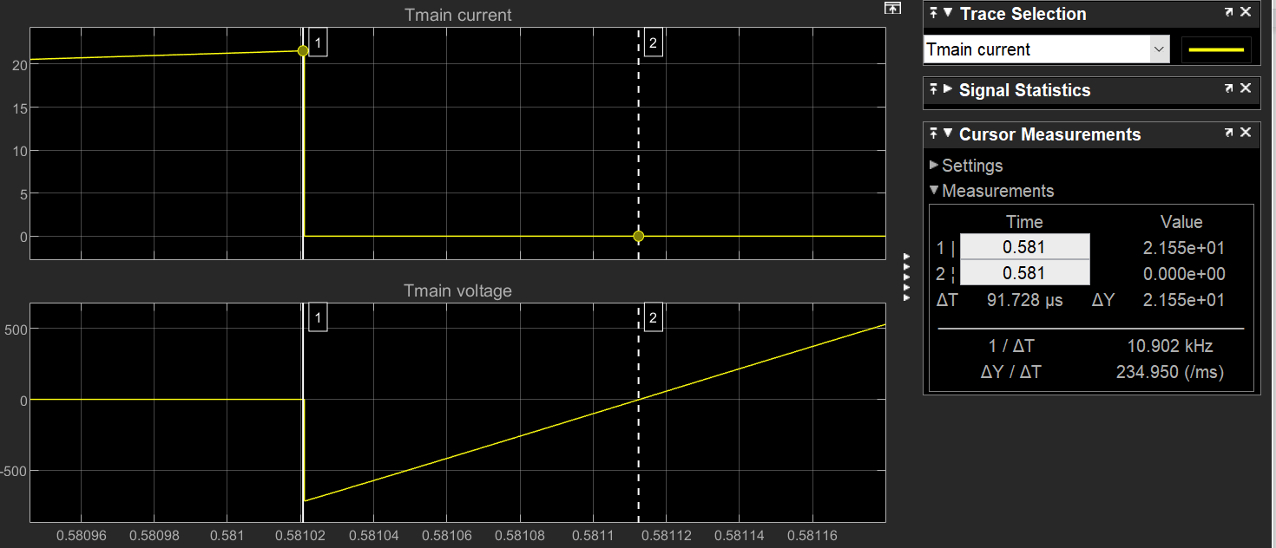

Toff = 0.0917ms

AUXILLIARY:

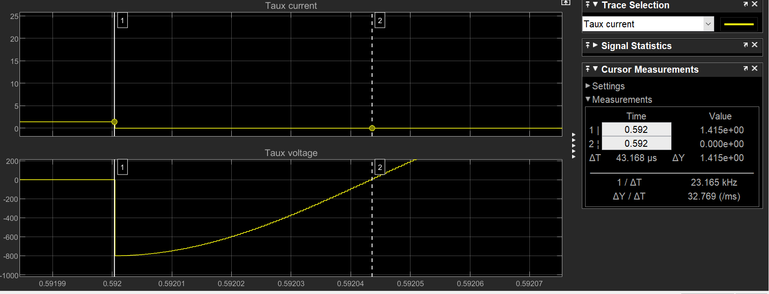

Toff = 0.043ms

(iii)

Voltage across Cc

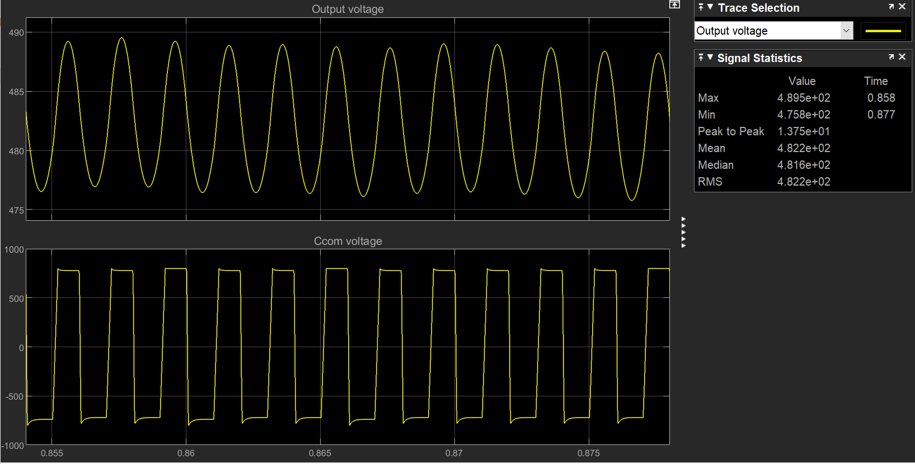

3 switching cycle of voltage across cc



(iv) Commutation failure of the main thyristor happens at Cc=77.5 nF approximately.

If we reduce the capacitance of the commutation capacitor, commutation failure occurs i.e. the turn-off time of the thyristor increases, hence due to switching the thyristor doesn’t have enough time to turn off. The turn-off time of the switch becomes insufficient for the thyristor to regain its blocking capacity and so it never turns off.

For a Cc value greater than 77.5nF, the thyristor is functioning perfectly as it has a lower turn-off time. At Cc=77.5nF, due to commutation failure, after the first few cycles in the transition state, the main thyristor voltage becomes 0, and current through it becomes constant (switch never turns off).

| Cc=3 micro F |  |
| --- | --- |
| Cc=0.1 micro F |  |
| Cc=80 nF |  |
| Cc=77.5 nF |  |
| Cc=75 nF |  |

**Discussion Questions:**

1. What are the advantages and disadvantages of thyristor-based buck converter over MOSFET-based buck converter?

**Mosfets** have a gate and can be controlled by this gate. They more or less act like a switch that can be on or off, controlled by the gate. Switching on to off and off to on is possible. The maximum switching frequency is quite high. (> 100 Khz). The MOSFET is a voltage-controlled device. Earlier, the MOSFETs were for the low powers and the high switching frequencies, and the IGBT's for the rest. Exotic semiconductors like SiC may have changed that a bit.

The **thyristor** is a current controlled device. Thyristors are switching devices that also have 2 states: on and off. They can only be switched from off to on with the gate. They switch off again if the current through them becomes zero. The switching frequency is much lower. They are available in very high power. They are only used for very high power applications, where the turn-off can be done by the circuit.

1. HVDC links (~2000 Mwatt link) inverters, where the turnoff is done because the load of the AC grid is capacitive.

2. Over-commutated synchronous motors were (again) the turn-off is circuit commutated because the motor current is capacitive.

**Disadvantages :**

Thyristors are also slow, [turn-off and turn-on time is also there]. A capacitor also needs time to recharge. A failed commutation may cause additional delay causing damage to the load if it fails to turn off.

There is also large noise, i.e. high currents associated with SCR trigger events.

The thyristor is a big component, even bigger due to the capacitor required.

**Advantages :**

A large amount of current is switched. The current rating of the thyristor is far too greater than MOSFETS.

They are also tremendously cost-effective, especially with advancements every day. Individual modules are parallel together to produce impressive results. With every passing day, they are becoming more powerful.

2. What will happen if the commutation capacitor voltage remains at zero throughout the operation?

The output will be equal to input voltage leading to commutation failure. The main thyristor will be always on.

3. While operating in an open-loop, why did we need to manipulate the Ton time of the converter to get desired o/p voltage?

It is needed to manipulate the Ton time of the converter, to get the desired o/p voltage. After firing the auxiliary thyristor at D*Ts, the commutator capacitor starts charging from -Vin to +Vin. Now the Freewheeling diodes turn on only when the capacitor reaches +Vin. This causes the main thyristor to be turned on for time more than required. So more output voltage is observed. Hence it is needed to reduce the value of the duty ratio (D) such that Ton (D*Ts) is reduced and we get the desired output voltage.